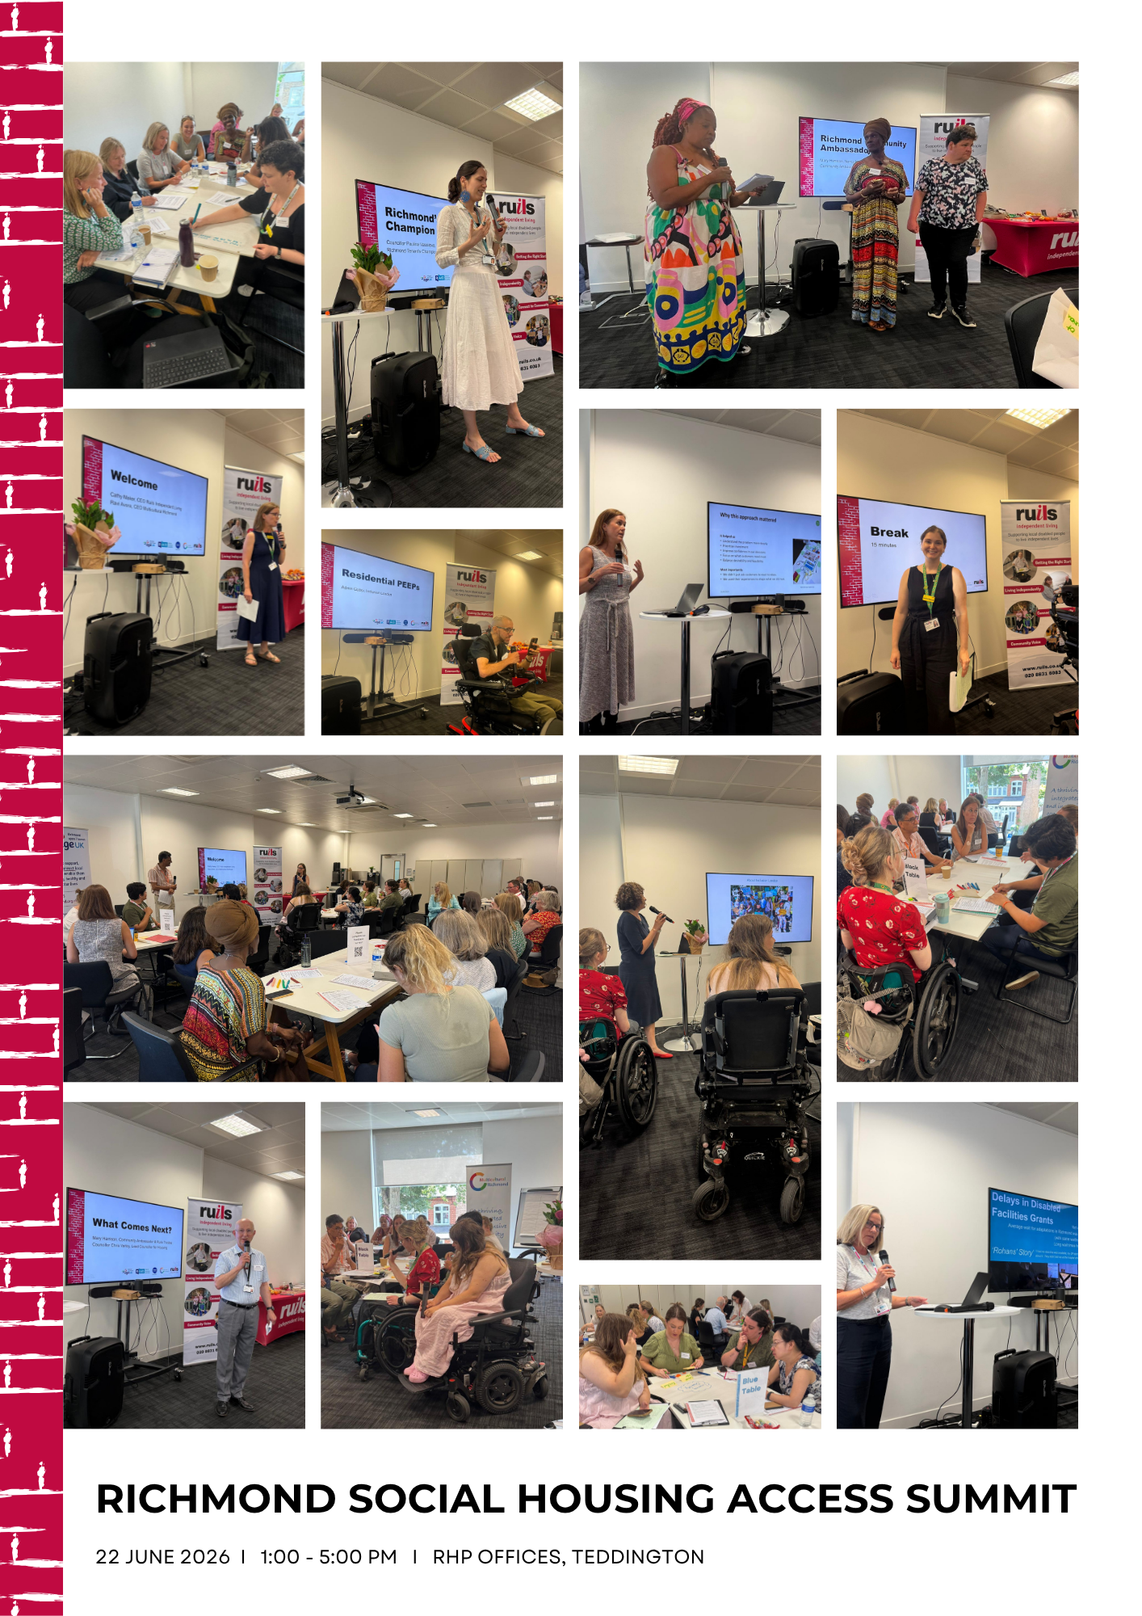

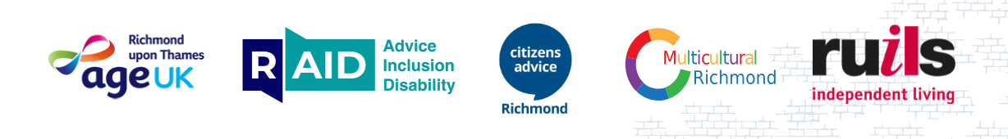

Richmond Social Housing Access Summit Wrap-up Report
On behalf of the Richmond Social Housing Collective, we want to thank everyone who attended the Richmond Social Housing Access Summit on 22nd June 2026. It was a great event and fantastic to have so many people in the room focused on improving accessibility for tenants in Richmond.
We have compiled the presentations and feedback from the interactive sessions in this report for you to review and see how you can embed recommendations/solutions into work at your respective organisations.

Reasonable Adjustments Session
Danielle Rampton and Lauren Rymel, Ruils Independent Living
Access the jargon busting document here, which was created to help us all understand key terms.
What are Reasonable Adjustments?
Under the Equality Act 2010, employers and service providers have a legal duty to make "reasonable adjustments" for Disabled people. This prevents Disabled people from facing substantial disadvantages in the workplace, education, housing or when accessing goods and services.
Specifically thinking about housing, reasonable adjustments are changes that housing providers can make to:
- remove barriers
- help tenants access services
- communicate effectively
- enjoy their homes
Key Learning Points
- The best adjustments are when the person is put at the centre their individual situation and access needs are considered.
- The best place to start is by asking – “What would help?”
- Reasonable adjustments aren't just about physical changes to a property.
- Adjustments can and should include communication, processes and the way services are delivered.
Group Activity – each group was given a specific impairment group and asked to discuss what reasonable adjustments might look like for that group.

Communication Needs
(PECS, Makaton, non-verbal communication, alternative communication methods)
- Record residents' communication needs and preferences at first contact and review them regularly, as needs may change over time.
- Ensure communication preferences are visible across housing management systems and shared appropriately with operatives, contractors and other staff involved in service delivery.
- Assign clear responsibility for maintaining and sharing communication requirements so information is not lost between teams.
- Offer multiple methods of communication, including face-to-face, telephone, email, text message, video call and supported communication methods.
- Provide information in accessible formats, including Easy Read, visual aids, PECS and Makaton-supported resources where appropriate.
- Use disability or accessibility champions/advisors to support staff and residents with communication needs.
- Be transparent about how and when residents can contact services, and what response times they can expect.
- Ensure timely, consistent responses and avoid requiring residents to repeat information multiple times.
- Use digital systems and apps to record and flag communication needs across the organisation.

Physical Impairments
(Wheelchair users and people using mobility aids)
- Increase the supply of accessible and adaptable homes, including homes built to M4(3) wheelchair-user standards where appropriate.
- Provide step-free access to homes and communal areas through ramps, level access routes and suitable pathways.
- Install and maintain lifts and ensure they are designed and operated safely, including fire evacuation considerations.
- Have contingency plans in place when lifts are out of service, particularly for residents who cannot use stairs.
- Provide stairlifts or platform lifts where appropriate.
- Install handrails and bannisters in communal and individual living spaces.
- Ensure doorways, corridors and circulation spaces are wide enough for wheelchair and mobility aid users.
- Provide accessible bathrooms, including properly designed wet rooms with suitable non-slip flooring.
- Offer adaptable kitchens that can be modified to meet changing needs.
- Install grab rails and other minor adaptations promptly where required.
- Take a proactive approach to assessing and delivering adaptations before residents reach crisis point.

Neurodivergent Residents
(Autistic people, people with ADHD and other neurodivergent conditions)
- Take a person-centred approach and recognise that every individual's needs and preferences are different.
- Ask residents how they prefer to communicate and engage with services.
- Provide flexibility in how appointments, meetings and services are delivered.
- Give advance notice of visits, meetings and repairs, including details of who will attend and what to expect.
- Allow residents time to prepare for conversations and provide written summaries afterwards where helpful.
- Maintain accurate records and ensure relevant information is shared appropriately between colleagues.
- Consider environmental factors that may affect residents, such as noise, crowding, lighting and sensory overload.
- Train staff to understand how neurodivergence may influence communication styles, behaviour and responses to stressful situations.
- Ensure written communications are clear, structured and accessible, including for residents with dyslexia.
- Focus on active listening and avoid making assumptions about behaviour or support needs.

Mental Health Conditions
(Anxiety, PTSD and other mental health conditions)
- Provide clear information about processes, timescales and next steps to reduce uncertainty and anxiety.
- Allocate a named contact or caseworker wherever possible to provide continuity and build trust.
- Offer trauma-informed approaches to service delivery, particularly for residents with PTSD.
- Make referrals to wellbeing, advocacy and support services straightforward and accessible.
- Create familiar and consistent points of contact for residents who may find engaging with services challenging.
- Consider proactive wellbeing check-ins for vulnerable residents, particularly during periods of significant change.
- Provide flexibility around appointments and communication methods.
- Recognise that some residents may find it difficult to initiate contact and may require additional outreach and support.

Sensory Impairments
(Deaf and hard of hearing people, blind and partially sighted people)

- Provide information in a range of accessible formats, including Braille, large print, audio and digital accessible documents.
- Arrange British Sign Language (BSL) interpreters where required.
- Ensure websites, portals and digital services meet accessibility standards and are compatible with assistive technology.
- Install and maintain appropriate safety systems, including accessible fire alarm systems.
- Provide residents with a designated point of contact where continuity would improve accessibility.
- Adopt a "tell us once" approach so residents do not need to repeatedly explain their access requirements.
- Offer communication and support outside standard office hours where appropriate.
- Provide person-centred responses that reflect individual needs and preferences.
- Develop peer support, ambassador and community-based support opportunities.
- Offer in-person support where digital or remote services create barriers.
- Be flexible and solution-focused, beginning from a position of identifying how access can be enabled rather than why it may be difficult.
- Clearly explain what support is available and what residents can expect from the service.

Learning Disabilities
(Down's Syndrome, developmental delay, dyslexia and other learning disabilities)
- Use clear, simple and jargon-free language in all communications.
- Provide information in Easy Read and other accessible formats.
- Offer face-to-face support where this improves understanding and engagement.
- Allow additional time for conversations, decision-making and completing processes.
- Be patient and flexible in service delivery.
- Identify support networks, advocates, carers or family members (with consent) who may help residents navigate services.
- Recognise different communication styles and adapt communication accordingly.
- Identify known triggers, barriers and support needs and tailor services appropriately.
- Use visual communication tools such as PECS where appropriate.
- Provide large print or dyslexia-friendly documents, including alternative fonts, layouts or coloured paper where beneficial.
- Promote independence while ensuring appropriate support is available when needed.
- Create environments where residents feel safe, respected and supported.

Intersectional Needs
(For example, disabled residents who also have English as an Additional Language)

- Recognise that residents may experience multiple barriers simultaneously and tailor support accordingly.
- Take a proactive rather than reactive approach to identifying accessibility and communication needs.
- Avoid generic responses and provide personalised support wherever possible.
- Use interpreters, translation services and accessible communication methods together when required.
- Train staff on intersectionality and the impact of multiple protected characteristics on access to services.
- Recognise that some residents may be reluctant or anxious about seeking help and may need additional encouragement and outreach.
- Ensure communication about available support is clear, accessible and culturally appropriate.
- Work with community organisations and trusted local partners to improve engagement and understanding of residents' needs.
- Record and share relevant accessibility requirements across services to reduce the need for residents to repeatedly explain their circumstances.
- Cross-cutting principles for all impairment groups
- Adopt a person-centred approach and avoid one-size-fits-all solutions.
- Ask residents what adjustments they need rather than making assumptions.
- Record adjustments once and make them visible across relevant systems.
- Regularly review and update residents' access requirements.
- Train all staff, contractors and operatives in disability awareness and inclusive communication.
- Ensure accessibility considerations are embedded into service design, housing management and repairs processes from the outset.
- Focus on removing barriers rather than expecting residents to adapt to services.

The State of Accessible Housing in London
Svetlana Kotova, Inclusion London
Download Svetlana’s presentation here.
Svetlana’s presentation highlighted Inclusion London's research, that found that many Deaf and Disabled Londoners are living in homes that are inaccessible, unsuitable and increasingly unaffordable. Despite London having ambitious targets for accessible housing, many boroughs are failing to meet them, and there is a shortage of accessible homes at social rent levels. The research also highlights that accessibility is about more than the home itself—it includes transport, local services and the wider environment. Significant gaps in data and planning are making it difficult to understand and meet current and future housing needs.
Key Learning Points
- Many Disabled Londoners live in homes that do not meet their access needs, including a lack of level access and other essential accessibility features.
- Accessible housing should be designed for a wide range of needs, including sensory, neurodivergent, mental health and visual impairments—not just mobility impairments.
- Accessibility of the surrounding area, including transport, healthcare and local services, is critical to independent living.
- Current accessible housing targets are often not being delivered, and there is insufficient focus on accessible homes that are also affordable.
- Disabled people face higher rates of poverty and housing insecurity, increasing demand for accessible social rented housing.
- Better data is needed to understand the supply of accessible homes and future housing needs.
Key Recommendations
- Accessible housing needs to be a strategic priority across planning, development and housing services.
- Increase the supply of accessible and wheelchair-accessible homes at social rent levels, not just specialist housing.
- Co-produce housing policies with Disabled people and Disabled People's Organisations (DDPOs) and Disabled people.
- Improve data collection, monitoring and enforcement of accessibility targets, particularly at the local authority level, so GLA data is accurate.
- Retain, adapt and retrofit existing homes to improve accessibility.
- Ensure accessibility and affordability are considered together when planning new housing.
Accessible housing is essential for independence, dignity and wellbeing. Increasing the supply of affordable accessible homes should be a priority for housing providers, local authorities and policymakers.

Residential PEEPs (Personal Emergency Evacuation Plans)
Adam Gabsi, Inclusion London
Listen to Adam’s presentation here.
Adam Gabsi, Chair of Inclusion London, shared a compelling call for housing providers to place the safety, accessibility and lived experience of Disabled residents at the heart of housing management and emergency planning. Speaking from his own experience as a resident living with Multiple Sclerosis, he argues that the changes introduced following Grenfell have not gone far enough to ensure Disabled people can evacuate safely in an emergency.
One of his key messages was that emergency evacuation planning must be based on the real needs of individual residents rather than a one-size-fits-all approach. Housing providers need to understand who may require assistance during an emergency, ensure residents' needs are identified and recorded and work proactively to remove barriers to safety.
He highlighted the importance of listening to residents' lived experiences. Adam describes how unreliable lifts in his own building left him uncertain whether he would be able to leave his home to attend the event. He emphasises that while a broken lift may be seen as an inconvenience by some, for many Disabled residents it can mean losing independence, becoming isolated or being unable to evacuate safely.
He also challenged housing providers to move beyond compliance and consider the human impact of their decisions. Behind every policy, consultation and regulation are residents whose safety, wellbeing and ability to live independently depend on effective housing management.
He stressed the importance of trust and communication. Residents need confidence that concerns about safety and accessibility are being acted upon, not simply acknowledged. Meaningful engagement, transparent communication and visible action are essential to building that trust.
Key recommendations
- Engage directly with Disabled residents and understand their individual circumstances.
- Review emergency evacuation arrangements to ensure they reflect actual resident needs.
- Treat lift reliability and accessibility as safety-critical issues, particularly in high-rise buildings.
- Move beyond compliance and consider residents' lived experiences when designing services.
- Build trust through action, communication and transparency.
- Recognise that independence and safety are closely linked for Disabled residents.
- Ensure resident voices are heard in discussions about housing safety and policy development.
Inclusion London have just launched their Toolkit for residents to help them navigate requesting a RPEEP.

Richmond Council Tenants’ Champion Service
Councillor Paulina Vassileva
For more information about the service, residents can visit the Richmond Council website and access the Tenants’ Champion referral form.
Download the 2025/26 Tenant’s Champion Report here.

Richmond Council has supported social housing residents since 2011 through initiatives including the Social Housing Improvement Plan (SHIP), developed with local housing associations to improve repairs, housing standards, sustainability, resident involvement and community safety.

The Tenants’ Champion Service provides independent support to social housing tenants and leaseholders who have ongoing complaints with their housing association. Residents can refer themselves through a simple online form or by contacting the Council.

The service works directly with residents, housing associations and partner organisations to help resolve complex cases, identify recurring issues and promote service improvements. It also brings together housing, health, community safety and voluntary sector partners through a twice-yearly Interagency Forum to strengthen partnership working and improve outcomes for residents.

A key focus of the service is supporting vulnerable residents, ensuring that disabilities, mental health needs and other access requirements are properly understood and reflected in service delivery through reasonable adjustments and person-centred approaches.

Through individual casework, partnership working and an annual report sharing lessons learned and good practice, the Tenants’ Champion Service helps ensure that residents’ voices are heard and that housing providers respond effectively to residents’ needs.

Engaging with Residents – Richmond Housing Partnership
Vickie Rubery, Business Transformation Team
Download the Repairs Service Adjustments Presentation here.
This presentation demonstrated the value of involving customers early in service design, particularly those who experience barriers when accessing repairs services. Rather than relying solely on internal assumptions, RHP worked directly with customers, case workers and community partners to understand lived experiences before making decisions. This co-production approach led to a deeper understanding of customer needs and increased confidence that proposed improvements would deliver meaningful benefits.
Key Learning Points
- Listen before designing solutions. RHP recognised that internally generated ideas needed to be tested against real customer experiences. Engaging customers and support organisations helped uncover needs that may otherwise have been overlooked.
- Accessibility is about more than physical or practical barriers. Initial discussions focused on issues such as answering the door, communication challenges, technology barriers, and memory or understanding difficulties. However, customer feedback revealed deeper concerns around anxiety, uncertainty, trust, waiting, and confidence in the service.
- Focus on underlying needs rather than specific solutions. Customers consistently wanted more certainty, preparation, reassurance and confidence throughout the repairs journey. Understanding these underlying needs helped shape more effective and customer-centred solutions.
- Returning to customers improves decision-making. A second workshop allowed RHP to test whether feedback had been interpreted correctly and whether revised ideas would achieve the intended outcomes. This iterative approach strengthened the quality of proposed improvements and avoided investing in solutions based on assumptions.
- Co-design helps prioritise resources effectively. Customer insight enabled RHP to focus investment on improvements most likely to have a positive impact while balancing customer needs with operational and technical feasibility.
- Accessibility improvements often benefit everyone. Many changes identified through the accessibility work—such as clearer communication, more notice, greater flexibility, and increased certainty—were found to improve the overall customer experience, not just for customers with additional needs.

As a result of the project, RHP progressed several improvements into delivery, including enhanced advisor scripts, clearer communications, better appointment information, arrival notifications, accessible written confirmations and improved discussions about customer preferences and support needs.
The strongest lesson from this work was that lived experience should be treated as expertise. By involving customers early, testing assumptions, returning with refined ideas, and focusing on needs rather than predetermined solutions, RHP was able to design a more accessible and customer-focused repairs service.

Jess Keane and Abbie Carter, Community Engagement Team
Download the Community Engagement Presentation here.
Download the August Community Engagement Schedule here.
This presentation highlighted how RHP has strengthened customer engagement by focusing on inclusivity, accessibility, visibility and relationship-building within its communities. A central theme was the importance of continually asking how services can be made more accessible for all customers, particularly those who may be vulnerable or less likely to engage through traditional channels.
Key Learning Points
- Being visible in communities improves engagement. RHP found that meeting customers where they are through drop-in sessions, door knocks, and estate walkabouts helps break down barriers and makes services more accessible.
- Face-to-face contact remains important. Customers value being able to speak directly with staff rather than relying solely on emails, voicemails, or digital communication channels.
- Supporting vulnerable customers requires proactive outreach. The team recognised the need to be more available and approachable, leading to initiatives that make it easier for customers to access support and raise concerns.
- Strong relationships are built through regular engagement. Community events, customer feedback opportunities, Community Champions, drop-in sessions and estate walkabouts all contribute to stronger connections between RHP and its residents.
- Customer feedback should drive improvement. Creating multiple opportunities for customers to share feedback helps ensure services evolve in response to resident experiences and needs.
- Partnership working increases impact. Collaboration with a range of community and support organisations helps extend reach, connect with diverse groups of residents, and improve outcomes for customers.

Customer feedback suggests that residents:
- Feel more heard and listened to.
- See action being taken on their concerns.
- Appreciate having direct contact with staff.
- Value the team's friendly, approachable, proactive, and professional approach.
- Feel that community engagement activities add a personal touch to service delivery.

Effective community engagement is not achieved through a single initiative but through a combination of visibility, accessibility, partnership working, proactive outreach and ongoing customer feedback. By creating opportunities for meaningful conversations and building relationships within communities, RHP has strengthened trust with residents and successfully engaged more than 500 customers through its community engagement activities.

Edward Phillips, Customer Experience and Engagement Manager
This session highlighted the breadth of opportunities available for customers to influence services and share feedback, demonstrating the importance of offering multiple engagement channels to suit different preferences and needs.
Key examples included:
- Providing a clear range of engagement opportunities through RHP's customer involvement framework and "Menu of Opportunities", helping customers understand how they can contribute to shaping services.
- Using accessible and proactive communications, such as the printed Go To Guide, which is posted to all customers to ensure important information reaches residents regardless of digital access.
- Gathering real-time customer feedback through transactional surveys sent immediately after service interactions, enabling RHP to capture timely insights and identify service improvements quickly.
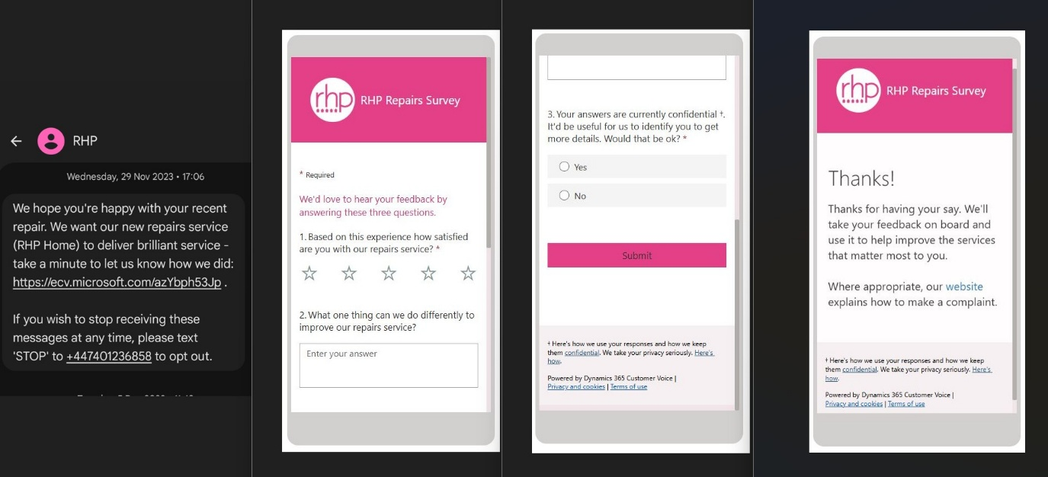
- Expanding digital engagement through the new Digital Neighbourhood platform, creating additional opportunities for customers to access information, connect with services, and participate online.
- Complementing digital channels with face-to-face engagement, including focus groups that allow for more detailed conversations and deeper customer insight.
- Improving inclusivity through service adjustments, with enhancements to the customer record system ensuring individual needs and adjustments are clearly captured and visible, helping colleagues provide more tailored support.
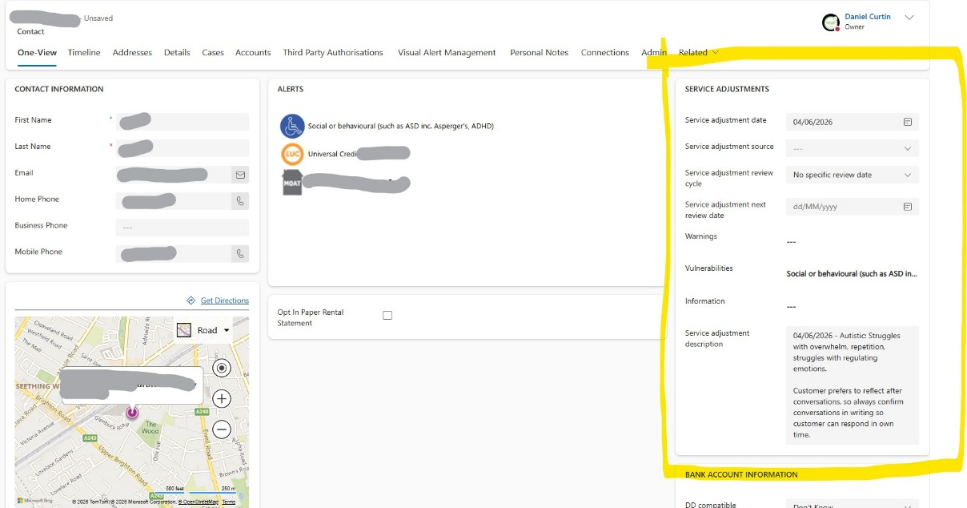
- Demonstrating the value of targeted service recovery initiatives, as illustrated by the success of the Hypercare Team in addressing a backlog of complex repairs following the transition from an outsourced contractor model to an in-house repairs service.
Overall, the discussion showcased how combining digital tools, traditional communications, structured feedback mechanisms and personalised support can strengthen customer engagement, improve service delivery, and ensure customer voices are embedded in decision-making.

Accessibility in Action
Hallie Banish, Ruils Independent Living
This session gave participants the opportunity to problem solve real accessibility issues that Disabled and marginalised tenants face in trying to engage with their housing providers. Four scenarios were distributed and groups were tasked with coming up with system solutions.
Download the group prompts here.

Key Learnings from Transformation Project 1 – Online Repairs System
Aisha Khan, a wheelchair user with chronic fatigue, repeatedly experienced failed boiler repair appointments because the repairs system did not properly capture, share, or act on her access needs. Unannounced engineer visits led to missed appointments, worsening health, a prolonged loss of heating, and ultimately a formal complaint that highlighted the impact on disabled residents. The case revealed a wider organisational failure in how access needs are recorded, communicated, and owned across systems, teams, and contractors, putting resident trust and Equality Act compliance at risk.
Requesting a Repair
The group identified the importance of capturing access needs at the very start of the customer journey.
- Ask residents about access requirements during initial contact.
- Obtain consent to record and share relevant information.
- Offer multiple communication channels, both digital and non-digital.
- Allow customers to choose appointment preferences, including specific time slots and advance notice before visits.
- Ensure residents can explain their needs in the way that suits them best.
Recording and Confirming Needs
- Accurate recording and communication of access needs is essential.
- Train staff in accessible communication and language.
- Confirm appointments with clear details, including date, time and tracking information.
- Record access needs consistently.
- Share relevant information with colleagues while protecting confidential personal data.
Delivering the Service
- Access requirements should be visible to those delivering the repair.
- Ensure engineers and contractors receive relevant access information.
- Provide automated notifications with arrival times or updates.
- Share engineer details, including name, photo or identification and estimated arrival time.
- Make access requirements a standard part of the repair process.
Follow-Up and Continuous Improvement
- Use every interaction as an opportunity to improve future services.
- Make it easy to reschedule appointments when needed.
- Capture information from visits to improve future customer experiences.
- Identify wider support needs and signpost residents to relevant services, charities or community support.
- Record learning from each interaction so access needs are recognised in future transactions.
- Provide customers with clear information about available support and guidance.
Access needs should not be treated as optional information. The group felt they should be proactively identified, consistently recorded, shared at the point of service, and used to shape the entire repair journey from booking through to completion.

Key Learnings from Transformation Project 2 – Life Change
David Morgan suffered a major stroke that left him unable to manage his tenancy or communicate with his housing provider, while his partner struggled to access support or understand what help was available. Because Horizon Homes relied on residents to report changes themselves, David's needs went unnoticed, leading to missed communications, worsening living conditions, and increased stress for both him and his partner. The case exposed a wider organisational issue: vulnerable residents often experience significant life changes without support.
Proactive Support
- Regular welfare check-ins and support visits.
- Use routine appointments (e.g. gas and electrical checks) to identify changing needs.
- Encourage residents to share life changes and update details regularly.
Early Identification & Safeguarding
- Use triggers such as missed payments, missed appointments, or non-engagement to flag potential concerns.
- Introduce welfare checks and referrals where residents disengage.
- Develop clear safeguarding and non-engagement procedures.
Better Communication
- Offer multiple contact methods, including home visits, phone calls, emails, and letters.
- Use clear, accessible, and supportive language.
- Keep emergency contact and next of kin information up to date.
Joined-Up Working
- Improve information sharing between teams and partner organisations.
- Strengthen links with health, social care, and voluntary sector services.
- Community Support
- Introduce local Tenant or Community Champions to help identify and support vulnerable residents.
Move from a reactive, self-reporting model to a proactive, preventative approach, using regular contact, early warning signs, and stronger partnerships to identify residents who may need support before issues escalate.

Key Learnings from Transformation Project 3 – Digital Exclusion
John Williams, an autistic resident experiencing persistent antisocial behaviour, struggled to access support because Horizon Homes relied on communication methods and processes that did not meet his needs. Repeated requests for help were channelled through scripted calls, online forms and generic responses, leaving him feeling misunderstood, overwhelmed and ultimately in crisis. The case highlighted how systems designed around a single communication style can unintentionally exclude residents, demonstrating the need for more flexible, personalised and accessible approaches to customer engagement.
Communication & Accessibility
- Offer a range of communication options, tailored to individual preferences.
- Ask residents how they prefer to communicate and record this from the outset.
- Use accessible formats, including easy-read communications.
- Recognise that communication needs may change over time.
Personalised Support
- Move away from rigid scripts and allow customer service teams to have more flexible conversations.
- Provide specialist customer advocates or disability advisors where needed.
- Offer a personal caseworker or single point of contact, particularly for complex cases and complaints.
Information Sharing & Ownership
- Use system alerts or pop-up notes to make communication needs visible to staff.
- Ensure communication preferences and support needs are passed on to relevant teams and operatives.
- Establish clear ownership for maintaining and sharing customer information.
Transparency & Support
- Improve signposting to available services and support.
- Be clearer with residents about what actions are being taken and what they can expect next.
- Provide timely responses to reduce uncertainty and build trust.
The group felt services should be designed around residents' individual communication needs, with greater flexibility, consistent points of contact, better information sharing and clear accountability for ensuring support needs are understood and acted upon.

Key Learnings from Transformation Project 4 – Transparent Communication
Maria Thompson reported a leaking ceiling and received only automated acknowledgements, with no meaningful updates or communication, leaving her unsure whether her repair request had been received or acted upon. As the leak worsened, duplicate requests, poor visibility of progress, and a lack of clear communication increased her anxiety and led to repeated contact attempts before the issue eventually became an emergency. The case highlighted that silence is often perceived as neglect, demonstrating the need for transparent communication, regular updates, and feedback loops that reassure residents they have been heard and informed about what happens next.
Communication & Responsiveness
- Offer multiple ways for residents to get in touch (phone, email, text, drop-ins, home visits).
- Provide immediate acknowledgement, a reference number, and rapid follow-up.
- Reduce call waiting times and ensure all contact channels are treated equally.
Prioritisation & Support
- Capture access needs and vulnerabilities from the outset.
- Introduce welfare checks and clear escalation routes for urgent cases.
- Prioritise repairs based on risk, vulnerability and legal requirements.
Ownership & Transparency
- Assign a named contact throughout the repair journey.
- Clearly link related repair requests to avoid duplication.
- Provide repair tracking so residents can see progress and next steps.
Systems & Knowledge
- Improve integration between systems to track and prioritise repairs effectively.
- Increase housing officer visibility and knowledge of tenants' circumstances.
- Invest in staff training and resident awareness of their rights.
Residents want clear communication, visible progress and accountability. The group felt that repair services should be easier to access, more responsive to vulnerability and provide greater transparency from first contact through to resolution.

Richmond Community Ambassadors
Mary Harrison, Nancy Mukaro and Anna Valancha Brown Community Ambassadors
The Richmond Community Ambassador Programme is a resident-led initiative designed to strengthen the connection between housing providers, the Council and local communities. Community Ambassadors are volunteers who act as a voice for their neighbours, helping to share residents’ views, identify local issues, influence decisions and work collaboratively to improve their neighbourhoods.
A key strength of the programme is that it places tenants at the centre of service improvement and community decision-making. Rather than relying solely on formal consultations, Community Ambassadors actively gather feedback from fellow residents, highlight concerns, support estate inspections and ensure that housing providers hear directly from the people who live in their homes. The Community Ambassador Programme demonstrates the value of moving beyond consultation and empowering residents to become active partners in shaping services and communities.
The scheme recognises that residents are experts in their own communities. Ambassadors help to:
- Share residents' views, ideas, and concerns with housing associations and the Council.
- Identify issues affecting estates and work towards solutions.
- Bring communities together through local initiatives and projects.
- Represent the voices of residents who may otherwise go unheard.
- Influence positive change in their neighbourhoods.
In the session, groups were asked to reflect on the following repairs scenarios and identify what operatives should do at each visit, how the outstanding repairs would be addressed and what the role of local staff (housing officers or neighbourhood coordinators) play in resolving issues.
Scenario 1 – An older tenant with hearing issues who doesn’t always hear the front door and struggles to hear when they have to phone in. Their repair is marked as ‘no answer’ so won’t be followed up.
- Do not assume "no answer" means the tenant is unavailable or unwilling to engage. Knock several times, wait longer than usual, and consider alternative methods of gaining attention (e.g. doorbell, visible presence at windows where appropriate).
- Check repair records for any recorded communication or access needs. This should be given automatically when repair booked.
- The repair should not be closed automatically as "no access".
- A follow-up appointment should be arranged using alternative communication methods such as letters, text messages or a pre-arranged appointment confirmation.
- The customer record should be updated to reflect the tenant's hearing needs and preferred communication methods. This could be done by the customer service team reaching out to capture updated access information. Work with the resident to agree a repair process that meets their needs in future.
- Consider a welfare check if there are repeated failed access attempts.
- Ensure communication needs/access needs are correctly recorded and visible to all teams and contractors.
Scenario 2 – A single mum whose first language is not English. When the operative calls, they refuse access as they don’t understand why he is there.
- Remain patient and professional.
- Do not force the visit or assume the resident is being uncooperative.
- Explain the purpose of the visit using simple language, identification and any translated information available.
- Record that access was refused due to a communication barrier rather than resident unwillingness.
- Rearrange the appointment through appropriate channels and with translation so the tenant understands what is happening.
- Ensure future appointment notifications clearly explain who is attending, why they are attending and when they will arrive in the correct language.
- Record language requirements on the customer record and come up with a plan to implement language requirements. Ensure these needs are visible to customer service, repairs teams and contractors.
Scenario 3 – When the operative calls at this home the tenant shows them a large black stain on a bedroom wall. What should the operative tell the tenant and what should they do when they return to the office?
- Take the concern seriously and avoid dismissing it as "just condensation" before investigating.
- Advise the tenant that the information will be reported and reviewed as a potential damp and mould concern and give a timeline that this will be done in.
- Record the issue in full, including photographs where possible and raise a damp and mould inspection or specialist survey request.
- Report any health concerns, vulnerabilities, or risks identified during the visit.
- Escalate the issue if there are signs of significant mould growth, structural defects, leaks or risks to health.
- Monitor progress to ensure the issue is not left unresolved and provide resident with regular updates.
- Educate tenant’s on their rights and what to expect under Awaab’s law.

Working with Case Workers – Trends and Insights
Emily John and Georgia Wukovich, Ruils Independent Living
Download the Working with Case Workers Presentation here.
This presentation highlighted the important role case workers play in helping housing providers understand and support residents, particularly those with vulnerabilities, access needs, or complex circumstances. The strongest message was that better outcomes are achieved when housing providers and case workers work collaboratively, communicate regularly and share information effectively.
Key Learning Points
- Consistent, timely communication between housing providers and case workers is essential.
- Acknowledging communications, even when a full response is not yet available, helps build trust and maintain progress.
- Case workers should be recognised as partners who can help providers understand resident needs, accessibility requirements, and barriers to engagement.
- Regular updates throughout a case enable case workers to support residents more effectively.
- Access needs and third-party consent should be captured and recorded accurately to ensure services are delivered appropriately.
- Providers should capture access requirements as early as possible, ideally at tenancy sign-up, and ensure this information remains visible and actionable.
- Dedicated teams for complex cases enable more coordinated and holistic support.
- Strong examples of customer service included responsive, empathetic communication and collaborative problem-solving between providers and support organisations.
- In-person feedback sessions help residents feel listened to, valued, and involved in decisions affecting them.
- Improve management of complex and high-risk disrepair cases, particularly where health and wellbeing are affected.
- Reduce the need for residents and advocates to escalate issues through complaints or legal action before receiving support.
- Better recognise and utilise the expertise of case workers, especially in relation to resident vulnerabilities and support needs.

Effective services are built on strong partnerships, proactive communication, and a shared understanding of residents' needs. Organisations that listen to and work closely with case workers are better placed to identify vulnerabilities early, resolve issues quickly, and deliver more accessible, resident-centred services.

Locked Out: Exploring Barriers Facing Deaf and Disabled People in Richmond
Jo Dixon and Clare Liddiard, RAID
Click here to Download the Locked Out Presentation.
This presentation highlighted the significant barriers that Deaf and Disabled residents face when accessing housing services, demonstrating that many systems are not designed with accessibility and inclusion in mind. The findings were co-produced with more than 350 Disabled residents in Richmond, ensuring lived experience was at the centre of the research.
Accessible Housing
- Being housed does not always mean a home is accessible or suitable for a resident's needs.
- There is a shortage of genuinely accessible homes, and existing housing records do not always accurately reflect accessibility requirements.
- Better data collection and greater involvement of Disabled residents in housing design and planning are needed.
Disabled Facilities Grants (DFGs)
- Awareness of available adaptations and support is low.
- Long waiting times for assessments and adaptations can have a significant impact on residents' quality of life.
- Processes should be reviewed to improve accessibility, awareness, and speed of delivery.
Housing Applications and Homelessness Services
- Online-only systems and complex application processes create barriers for many Disabled residents.
- Residents need accessible formats, simpler processes, longer timeframes and access to in-person support.
- Services should be designed with Disabled people rather than for them.
Repairs and Disrepair
- Damp, mould, leaks and unresolved repairs continue to have a significant impact on Disabled residents.
- Poor communication and slow repair processes often worsen customer experiences.
- Repairs services should incorporate access needs and provide more face-to-face engagement opportunities.
Partnership Working
- Positive progress is being made through stronger collaboration between housing providers, local authorities and voluntary sector organisations.
- Increased tenant engagement and more accessible ways to interact with services are helping to improve outcomes.

The strongest theme throughout the presentation was that accessibility should be embedded across the entire housing journey—from applications and allocations to repairs and adaptations. Co-designing services with Disabled residents, improving communication, removing unnecessary barriers and recognising lived experience as expertise are critical to creating more inclusive housing services.

What Comes Next?
Mary Harrison, Community Ambassador & Ruils Trustee
Councillor Chris Varley, Lead Councillor for Housing
We finished the day with some reflections from Mary Harrison on her journey as a tenant, Community Ambassador, Trustee and campaigner. She poignantly shared how her experience advocating for change in the social housing sector has helped her grow in confidence and feel that her voice matters and can make a difference.
Councillor Varley, Lead Councillor for Housing at Richmond Council, reflected on the importance of this collective work, highlighting the council’s commitment to making sure that all have suitable housing. In addition to the council’s work on specialist housing provision, he highlighted how the Community Ambassadors, Social Housing Improvement Plan and Tenant’s Champion work together to meet resident’s needs and help amplify tenant voices/experience.

Contact
If you have any questions about this wrap-up report or would like to be put in touch with any of the speakers, please get in touch with Hallie Banish, halliebanish@ruils.co.uk or 07908 616082.

