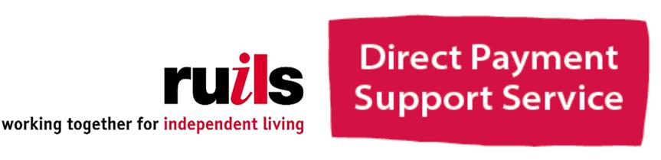

DIRECT PAYMENT FORUM
Ruils would like to invite you to the first of our DP forums. The aim of the forums is for you to meet other people who are also in receipt of Direct Payments to talk about things you all have in common. Whether you are an employer, use our payroll or managed account services or just want to know about what we do here at Ruils DP Support Service, please join us.

A light lunch and drinks available
Guest speaker from Mark Bates Insurance will talk about employer responsibilities.

Where: Ruils office – The DAAC, 4 Waldegrave Rd, Teddington, TW11 8HT (next to Teddington Library)
When: Tuesday 11th September 1pm – 3pm

This will be a regular forum with guest speakers so please let us know if you have suggestions. Our offices are fully accessible and if you would like further information please call us on 020 8831 6088

